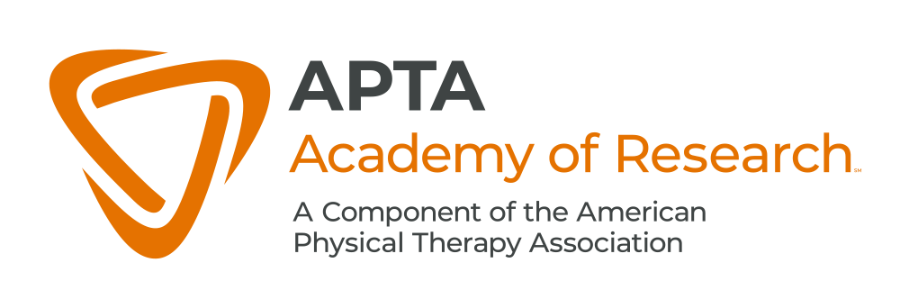

Media

This is a non-exhaustive list of various qualitative and mixed-methods media topics that can be utilized to assist in developing the content of a Doctor of Physical Therapy Program. If you would like to submit for possible inclusion additional qualitative or mixed-methods media content, please submit your suggestion to the Qualitative and Mixed-Methods Toolkit team.

PODCAST: The Words Matter Podcast with Dr. Oliver Thompson  The Qualitative Research Series |  | https://podcasts.apple.com/us/podcast/the-words-matter-podcast-with-oliver-thomson/id1504266736
PODCAST: Between the Data  NVivo Podcast Series |  | https://podcasts.apple.com/us/podcast/between-the-data-nvivo-podcast-series/id1510812834
PODCAST: Qualitative Conversations  Qualitative Inquiry Special Interest group of the American Educational Research Association |  | https://www.podomatic.com/podcasts/aeraqrsig
PODCAST: Ethnography Atelier Podcast |  | https://www.ethnographyatelier.org/podcast
PODCAST: HMP Governance Lab: Qualitative Methods for Health Policy Research |  | https://www.buzzsprout.com/1546609
PODCAST: Qualitative Open Mic  Qualitative Applied Health Research Centre |  | https://www.quahrc.co.uk/podcasts-blogs/the-qualitative-open-mic-podcast
PODCAST: Research in Action  April 2016, RIA #2: Dr. John Creswell on Mixed Methods |  | https://ecampus.oregonstate.edu/research/podcast/e2/
VIDEO: @GradCoach YouTube |  | https://www.youtube.com/channel/UCUZQe2d7Busejo7-s55YjkA/featured
VIDEO: E-Learning Qualitative Methods |  | https://www.youtube.com/@e-learningqualitativemetho6758/videos
VIDEO: GROUNDED THEORY EXPLAINED IN SIMPLE TERMS |  | https://www.youtube.com/watch?v=tirZ7ktPW64
VIDEO: Qualitative Reasearch Design: Phenomenology |  | https://www.youtube.com/watch?v=3aYRlNrO6oA
VIDEO: Understanding Phenomenology |  | https://www.youtube.com/watch?v=d5geMLe5tbM
VIDEO: Ethnography |  | https://www.youtube.com/watch?v=aOBh8haj4E0
VIDEO: What is Ethnography and How does it work? |  | https://www.youtube.com/watch?v=_c1SUHTG6B8

